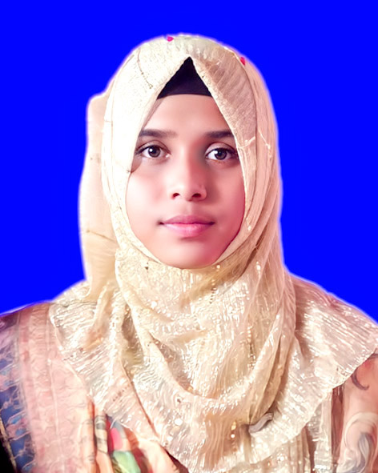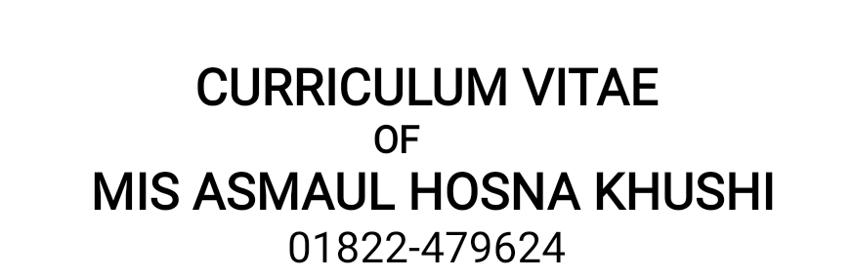



**Mailing Address:**

hfj

Mis Asmaul Hosna Khushi

C/O- Md. Sujaur Rahman

Village: Khalisha Khutamara, Post: Khutamara- 5330, Upzilla: Jaldhaka, Zilla: Nilphamari.

Mobile: 01822-479624

Email:asmaulhosnakhushi26@gmail

GitHub:https://github.com/asmaulhosnakhushi26

Linkedin:https://www.linkedin.com/in/mis-asmaul-hosna-khushi-ba4443342

Fiverr:https://www.fiverr.com/asmaulkhushi26/buying?source=avatar_menu_profile

E



**Career Objective**

To work in a dynamic, intensive environment, where the creativity and interest can be found to develop the skills as well as the career with a strong emphasis on sustained growth and development.

**Academic Records**

**Higher Secondary Certificate (HSC)**

Institute Name **: Tengonmari Degree College, Nilphamari.**

* Board **:** Dinajpur
* Group **:** Humanities
* GPA **:** 4.33 (5.00)
* Passing Year **:** 2019

**Secondary School Certificate (SSC)**

* Institute Name **: Tengonmari M.L High School, Nilphamari.**
* Board **:** Dinajpur
* Group **:** Science
* GPA **:** 4.18 (5.00)
* Passing Year **:** 2017

\

**Language Proficiency**

Good command in Speaking and writting in both Bengali, English.



**Personal Details**

Name : Mis Asmaul Hosna Khushi

Father’s Name : Md. Sujaur Rahman

Mother’s Name : Miss. Rashida Begum

Persent Address : Vill: Khalisha Khutamara, Post: Khutamara - 5330

Upzilla: Jaldhaka, Zilla: Nilphamari.

Permanent Address : Vill: Khalisha Khutamara, Post: Khutamara - 5330

Upzilla: Jaldhaka, Zilla: Nilphamari.

Nationality : Bangladeshi (by birth)

Date of Birth : 12-05-2001.

Religion : Islam

Marital Status : Unmarried.

Sex : Female.

Height : 5`3``

Blood Group : B (+)

National Id No : 1511584284

Weight : 48 KG

Computer Experience 

Auto Cad, Ms Word, Ms Accescc, Ms Excel And Internet Browsing. 

Experience

Training:

**1.Computer Fundamentals and Office Applications Training**  
Organized by Bangladesh Computer Council and Center for Digital Transformation (CDT), Begum Rokeya University, Rangpur  
Funded by Enhancing Digital Government & Economy (EDGE) Project  
Year of Completion - 2025

* Gained proficiency in basic computer operations and Microsoft Office applications.
* Hands-on experience with tools like Word, Excel, PowerPoint, and others.
* Learned essential skills for digital government services and economic applications.

2. Complete four month Training NSDA Level- 03 AUTO CAD in Nilphamari Technical Training Center. (TTC).

3. Complete 360 hours Training NSDA Level- 03 Computer Operation in Eco Institute of Technology (EIT) Under Bangladesh Technical Education Board (BTEB).

**Self Appraisal**

The followings are true for me –

* I am pious and assiduous. By the grace of God, I can learn anything very quickly.
* I like challenges and I enjoy challenges, I am never slack in doing my duties.
* I am punctual and truthful.

**Declaration**

I hereby declare that all the details furnished here are true to the best of my knowledge and belief.

Signature....................................

Mis Asmaul Hosna Khushi

Date: